application of emotional engineering techniques in the gastronomy sector.
N. Campos, R. Marzo, C. Soriano, S. Santiago, M.J, Such.
abstract

Biomechanics Institute of Valencia (IBV) and Masía Xamandreu have applied in a pioneer way Emotional Engineering techniques in the gastronomy sector, which is one of the most important in Comunidad Valenciana and Spain. These techniques enable to study the relationship between the emotional concepts that the company wants to transmit and the messages perceived by the clients through the visual assessment of food arrangements.

Emotional Engineering Techniques are used to obtain knowledge that allows relating technical, functional and aesthetic characteristics of the products with user’s emotions. The application of this methodology in food arrangements is very innovative internationally, and allows to understand the relationship between the brand values of Masía Xamandreu and plate design. Therefore it is possible to determine which combination of design elements maximizes this perception, and therefore increases the probability that consumers choose the restaurant.

Keywords: Emotional perception, stimulus, conjoint analysis, restaurant buying behavior, dish design, restaurant’s brand values.
introduction

In today’s highly competitive and dynamic market, differentiation of products and services is getting more and more challenging. As markets are being flooded with products and services offering similar functionalities, price and aesthetics, emotional appeal is increasingly gaining relevance as a source of added value and competitiveness.

Furthermore, it is widely accepted that consumer‘s satisfaction does not only depend on product´s or service´s performance and price. People also demand an “extra” quality in terms of symbolic value and image transmitted through product appearance (Darden et al. 1994), being both of them closely related to people’s perception. Aspects such as function, performance, efficiency and ergonomics can be conveyed to some extent by the visual appearance of the product (Nathan et al., 2004), which can arise in the observer expectations of what the other senses will perceive (Monö, 1997; Desmet, 2003). Thus, emotional response of customers is, in the end, derived from their perception of product attributes, in which the visual perception plays a key role (Schifferstein, 2008). In fact, 70% of the body's sense receptors cluster in the eyes (Ackerman, 1991). Some authors also support a relevant influence of emotional appeal in customer perception of service quality, customer loyalty and purchase intention (Upah et al. 1981; Young 1981; Mattila, 1999).

Therefore, it could be stated that in the emotional realm, perception is a powerful tool to convey an attractive service or product experience. As a consequence, some products, services and environments make people fall in love. But why? Biomechanics Institute of Valencia (IBV) studies people’s perceptions, needs, emotions, demands and expectations for helping companies to adapt products and services not only to their needs but also to their feelings and sensations.

However to extract and select valid and related information from users for the design of products and services is not always easy. That is why IBV combines different methodologies, technologies and resources based on the study of the user as a complex entity who think, say, do, feel and perceive to obtain knowledge that allow developing products, services and environments whose design cause a favorable, satisfactory and pleasant answer to the client.
These techniques enable to translate efficiently the analysis of customer behavior into design criteria for developing products, services and environments which satisfy users’s emotional and multisensorial expectations.

This analysis can be obtained using either quantitative or qualitative methods, both included in what it coud be stated Emotional Engineering. An example of a qualitative framework is that suggested by Jordan (2000), who suggested a hierarchy of product appreciation similar to Maslow’s (1968) hierarchy of needs. In Jordan’s hierarchy the basis is functionality; the second level in the hierarchy is concerned with usability. The third and final level is denoted “pleasure” and has to do with appreciation based on aspects that are harder to anticipate, e.g. cultural values and personal preferences. Jordan quotes Tigers (2000) framework of four pleasures and describes how products can evoke social, ideological, physiological or psychological pleasures. As competition increases, it becomes more important to meet the higher objectives in the hierarchy. Speaking solely about different pleasures may be limited, and provides only slightly more information than an approach focusing on satisfaction or delight. In reality, humans display a wide variety of different emotions in relation to product interaction, and these emotions may influence both the general well-being of the user and the purchase decision. Desmet (2002) studied emotions in relation to images of products and developed an instrument to measure seven unpleasant emotions (Indignation, contempt, disgust, unpleasant surprise, dissatisfaction, disappointment, and boredom) and seven pleasant emotions (desire, pleasant surprise, inspiration, amusement, admiration, satisfaction, and fascination) in relation to product appearance.

One example of a quantitative method is that used by Kansei Engineering (Nagamachi, 1995), which describes the relation between users and products by looking at how different design attributes correlate with the feelings of users. It was developed in Japan in the 1970s and was defined by its creator Nagamachi as a technology for translating consumer feelings and images of a product into design elements. Products are evaluated on semantic differential scales (Osgood et al., 1957) and also categorized with respect to their attributes (e.g. color and shape). Statistical methods are then used to find correlations between attributes and perceived expression or users’ feelings. This statistical data is used in the development of new products to make inferences from the feelings elicited by the properties of a new design. Another quantitative method is Conjoint Analysis, which measures consumer preferences on the attributes of a product or service (Aaker and Day, 1986). Conjoint Analysis data can be recorded using two different methods: the two-factor-at-a-time tradeoff method or the multiple factor full-concept method.

Emotional Engineering has been successfully applied to a range of industrial sectors, such as furniture, flooring, cars and footwear. However, this method has rarely been applied to the entertainment, hospitality and catering sector and, in the specific case of dish design, we know of no examples of its application.

The global importance of Spanish cuisine today, driven by creative and innovative cooking styles, confirm consumer trends towards a search for complex, high quality and indeed emotional and hedonistic experiences. In this scenario, the overriding goal of the research presented in this paper was to offer a more meticulous and coherent way of designing dishes that better matches the type of sensations the customer wants to experience and that will influence their choice of a restaurant.

This project arose from the management of La Bona Tradició’s interest in innovation and superlative quality in the form of People Oriented Design techniques, which are new to the catering industry. LA BONA TRADICIÓ, S.L. is a Valencian company that manages events catering design, management, preparation and service, using facilities at the Masía de Xamandreu restaurant.

materials, techniques and methodology

Emotional Engineering was used to identify successful design elements. Emotional Engineering has tools that allow one to objectively and reliably check emotional responses deriving from the interaction of the senses and concept transmission right from the early design stages. This type of tool also allows one to link design elements with the perceptions they generate in consumers, thereby achieving greater probability of restaurant choice.

This project was organised into four phases:

In the first phase, the project parameters were set out. Firstly, it was decided which dish design elements would be analysed, both for desserts and appetizers, as well as the categories or attributes corresponding to each of them. Secondly, the brand values that the company wanted to transmit were defined: “design”, “appetizing”, “exclusivity” and “surprise”. Finally, it was important to work with consumers that fit the profile of a Masía Xamandreu customer (Valencian, middle to high socio-economic level and spread across two age groups – young and older people).

In the second phase, the different sense stimuli to be evaluated were developed. The selection and configuration of stimuli is considered one of the key phases of the project, given that the products evaluated have to correspond to an orthogonal, factorial design and allow for the identification of key elements for the transmission of emotional messages. The team of professionals at La Bona Tradició were asked to create each of the stimuli and a team of technicians from IBV (Biomechanics Institute of Valencia) recorded the images and produced some files simulating the Masía de Xamandreu website, with a picture of each of the dishes (Figure 1).
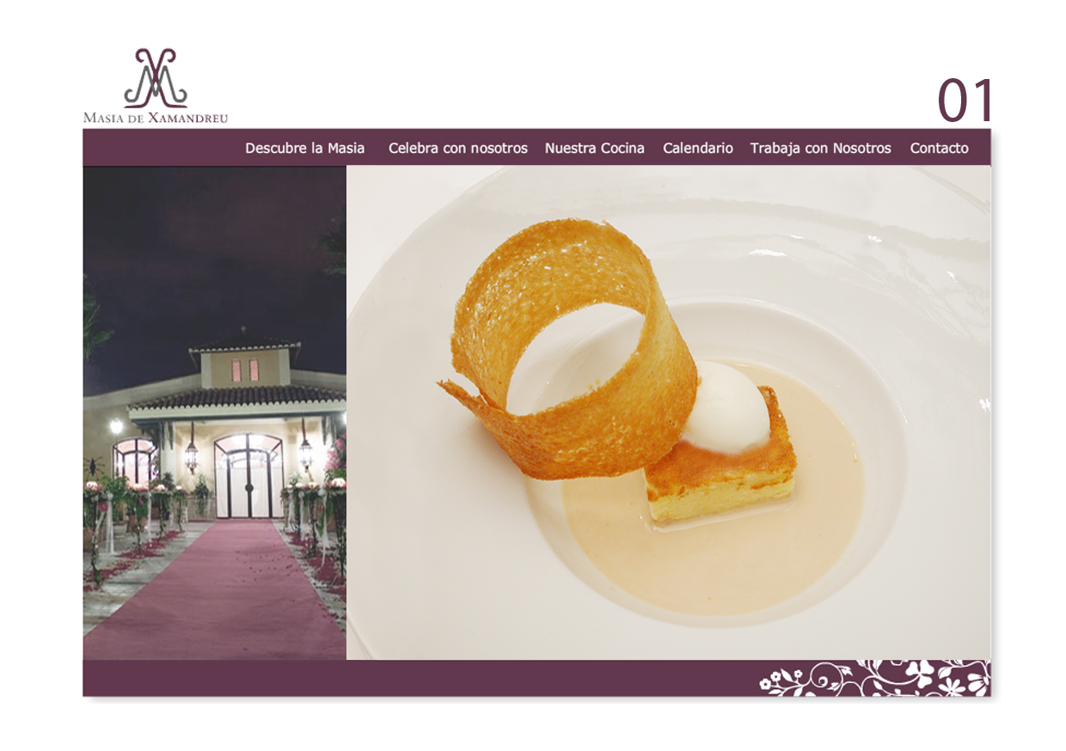
Figure 1: Example of file for consumer evaluation.

In the third phase, the emotional studies were conducted in the facilities of the Biomechanics Institute. Consumers evaluated the various dishes, based on the semantic themes that fit with the brand values. This evaluation was conducted by means of visual perception of the files, in a simulated search for a restaurant in which to hold a wedding banquet.

Fifty-one people (27 users from 26 to 45 years old and 24 from 56 to 75 years old) took part in these studies.

In the fourth phase, a statistical analysis was made in order to identify (for desserts and appetizers) how design factors influence the emotional perception of brand values and the attributes of each factor that should be used to maximise this perception. The brand values that most positively influence restaurant choice were also identified. These analyses were made on a general level and in relation to different consumer profiles.
Results
The most significant conclusions of the study, both for desserts and appetizers, are as follows:

For the desserts, we obtained the results outlined in Figure 2, which shows that the shape of the crispy element and the structure of the dessert are the design elements that most influence the perception of the emotional themes. They should therefore be especially kept in mind when aiming to transmit a particular brand value. It was also found that the second most influential factor was the colour of the crispy element. Finally, the colour, shape and size of the ice-cream had a low degree of importance.

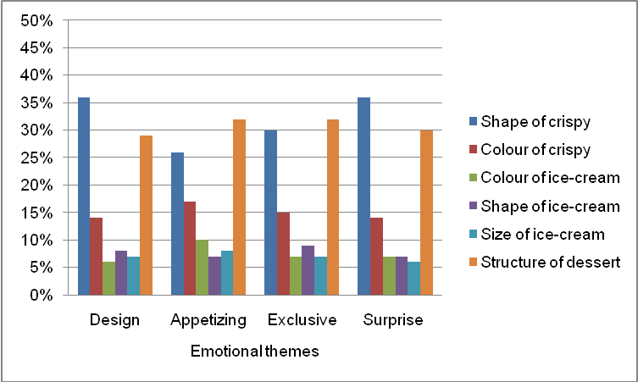
Figure 2: Influence of dessert design elements on the emotions researched.

The results of the attributes analysis found that the cylindrical shape of the crispy element combined with a solid or mix structure (never liquid) of the dessert are what generate the greatest perception in each of the emotions. The structure must be liquid Differences in the colour of ingredients were also found, light colours being more appetizing and dark colours more exclusive and surprising. Table 1 shows the combination of attributes that maximise and minimise each of the emotions.

- Combinations that maximise the perception of attributes. Desserts
EMOTIONS | Shape of crispy | Colour of crispy | Colour of ice | Shape of ice | Size of ice | Structure | Usefulness
Design | Cylindrical | Light | Dark | Quenelle | Big | Mix | 95.21%
Appetizing | Cylindrical | Light | Light | Spherical | Small | Mix | 89.03%
Exclusive | Cylindrical | Dark | Dark | Quenelle | Big | Mix | 99.65%
Surprise | Cylindrical | Dark | Dark | Quenelle | Big | Mix | 98.13%

- Combinations that maximise the perception of attributes. Desserts
EMOTIONS | Shape of crispy | Colour of crispy | Colour of ice | Shape of ice | Size of ice | Structure | Usefulness
Design | Rectangular | Dark | Light | Spherical | Small | Liquid | 33.21%
Appetizing | Rectangular | Dark | Dark | Quenelle | Big | Liquid | 26.91%
Exclusive | Rectangular | Light | Light | Spherical | Small | Liquid | 29.86%
Surprise | Rectangular | Light | Light | Spherical | Small | Liquid | 33.78%
Table 1: A: Combinations of attributes that maximise the perception of brand values in desserts.
B: Combinations of attributes that minimise the brand values in desserts.

In terms of the influence of the brand values when choosing a restaurant, the results show that the most influential value was the design of the dessert (51%), followed by the perception of exclusivity (27%), appetizing dessert (21%) and finally, the perception of surprise, which had hardly any impact at all (1%) (Figure 3).

Figure 3: Importance of the brand values on the choice of a restaurant for desserts.

Concerning the appetizers, we obtained the results shown in Figure 4, which shows that the garnish is the element that most influences all the emotions, followed by the colour and the receptacle. The shape and size of the appetiser are the elements that least influence the four emotions.

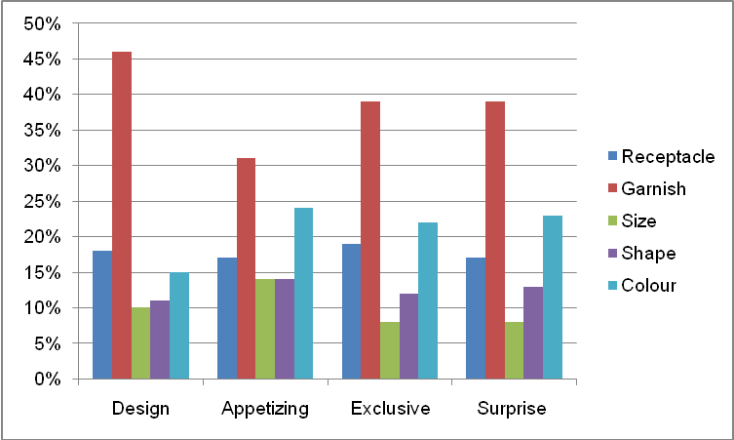
Figure 4: Influence of appetizer design elements on the emotions researched.

The results of the attributes analysis showed that a “full” garnish made up of sauce, toile and salad is what maximises perception for each of the emotions and a garnish made up of only sauce minimises it. The larger sizes (2 mouthfuls) also maximise the perceptions of all the brand values and the smaller appetizers (1 mouthful) minimise them. The white colour is considered the most appetizing and red is seen as the most exclusive, fashion and surprising. Regarding the receptacle, the plate is perceived as design and appetizing, although, the metal spoon as exclusive and surprising. Table 2 shows the combinations of attributes that maximise and minimise each of the emotions.

- Combinations that maximise the perception of attributes. Appetizers
EMOTIONS | Receptacle | Garnish | Size | Shape | Colour | Usefulness (%)
Design | Plate | Sauce+toile+ salad | 2 mouthfuls | Sphere | Red | 91.96%
Appetizing | Plate | Sauce+toile+ salad | 2 mouthfuls | Cube | White | 88.88%
Exclusive | Metal spoon | Sauce+toile+ salad | 2 mouthfuls | Cube | Red | 88.54%
Surprise | Metal spoon | Sauce+toile+ salad | 2 mouthfuls | Cube | Red | 90.41%

- Combinations that maximise the perception of attributes. Appetizers
EMOTIONS | Receptacle | Garnish | Size | Shape | Colour | Usefulness (%)
Design | Metal spoon | Sauce | 1 mouthful | Cube | White | 26.93%
Appetizing | Metal spoon | sauce | 1 mouthful | Sphere | Black | 27.97%
Exclusive | Plate | Sauce | 1 mouthful | Sphere | White | 26.17%
Surprise | Porcelain spoon | sauce | 1 mouthful | Sphere | White | 28.52%
Table 2: C: Combinations of attributes that maximise the perception of brand values in appetizers.
D: Combinations of attributes that minimise the brand values in appetizers.

As regards the influence of brand values when choosing a restaurant, the results showed that the most influential value was the design of the appetizer (64%), followed by surprise (25%), appetizing starter (9%) and exclusivity (2%) (Figure 5).

Figure 5: Importance of the brand values on the choice of a restaurant for appetizers.

No significant differences were observed between the consumer groupings (young and older people) for desserts. However, concerning the appetizers, results showed that the perception of the design emotion was maximized within older people and the porcelain spoon within young people.

Older people consider that the red colour is a bit more appetizing than the white colour.

Below, we show the design of the dessert and appetizer dishes that would most increase the probability of choosing the restaurant (Figure 6). These designs correspond to the combination of attributes that maximise the perception of the “design” value, as this is the brand value that most influences the choice of restaurant, both for desserts and appetizers.

Figure 6. A: Best design for dessert dish. B: Best design for appetizer dish.

CONCLUSIONS
The brand value that more influenced in a restaurant’s election is the “design”. A crispy element and a solid structure maximize the perception of design for desserts. Regarding the appetizers, these elements are the garnish, the receptacle and the colour. Finally, light colours are related to the “appetizing” emotion and dark colours to design, exclusivity and surprise.

The study has led to a more meticulous design of the emotional experiences that are consistent with the type of sensations that the customer wants to experience and that have an influence on him/her choosing La Masía. This has been done by designing dishes to be featured on the website, a fundamental tool in the consumer’s initial purchasing experience. In order to continue to improve the company’s positioning in the market, work should continue with all the elements involved in the purchasing experience of La Masía de Xamandreu’s customers with further intervention on product presentation, for example, managing the customer’s involvement with the brand or incorporating new technologies or services at the point of sale.

Acknowledgements

To La Masía Xamandreu, its management team and employees, for making this project possible. This project was funded by the Ministry of Industry, Tourism and Trade through the National Programme of Applied Research Projects.

References

Aaker,D.A. Day, G,S,.1986. Marketing Research.Wiley, New York.

Darden. William & Babin. Barry. (1994). Exploring the concept of Affective Quality: Expanding the concept of Retail Personality. Journal of Business Research. Vol. 29. Nº 2 . 101-109.

Desmet, P.M.A., 2002. Designing Emotions. Delft University of Technology, Delft.
Desmet. P.M.A.,2003. Measuring emotion; development and application of an instrument to measure emotional responses to products. In: M.A. Blythe. A.F. Monk. K. Overbeeke. & P.C. Wright (Eds.). Funology: from usability to enjoyment. (Dordrecht: Kluwer Academic Publishers: 111-123.
Desmet. P.M.A., Hekkert P.,2007. Framework of Product Experience. Internation Journal of Design. Vol 1: 57-66.
Jordan, P.,2000. Designing Pleasurable Products: An introduction to the new human factors. Taylor & Francis, London.

Maslow,A., 1968. Toward a Psychology of Being. Van Nostrand, New York.

Monö. R.,1997. Design for product understanding Liber. Stockholm. Sweden.
Nagamachi, M.,1991. An image technology expert system and its application to design consultation. Int J Human Comp Interaction 3(3):267-279
Nagamachi, M.,1994.Implication of Kansei engineering and its application to automotive design consultation. In: Proc Third Pan-Pacific Conf Occup Ergonomics. Ergonomics Quality Life. Seoul. pp 171-175
Nagamachi, M.,1995. Kansei Engineering: a new ergonomic consumer-oriented technology for product development. Int J Ind Ergonomics. 15(1):3-11
Nagasawa, S.,1997. Kansei evaluation using fuzzy structural modelling. In: Nagamachi M (ed.) Kansei engineering-I: Proc first Japan-Korea Sympos on Kansei Engineering -Consumer- Oriented product development technology. Kaibundo. pp 119-125
M. Nagamachi, Kansei engineering: the framework and methods. In: M. Nagamachi, Editor, Kansei Engineering 1, Kaibundo Publishing Co. Ltd, Kure (1997), pp. 1–9.
Nathan, Crilly. James Moultrie and P. John Clarkson.,2004. Seeing Things: response to the visual domain in product design. Design Studies. 25. 547-577.
Osgood, CE. Suci GJ.,1955. Factor analysis of Meaning. J Exp Psychol 50(5):325-338
Osgood, CE. Suci GJ. Tannenbaum, PH.,1957. The measurement of meaning. University Illinois Press
Tiger, L.,1997. The pursuit of pleasure. Transaction Publishers, New Brunswichk.

