TITLE OF CONTRIBUTION (CENTERED, BOLD LETTERS ARIAL SIZE 12 POINTS)
Presenting Author,ª Second Authorª , Third Author^{b}…
ªAuthor affiliation
^{b}Author affiliation
e-mail: presenting_author@xx.xx
Keywords: keyword1, keyword2 …
Indicate one of the following areas:
AMatS1.- Graphene and other 2D materials.
AMatS2.- Materials for Energy.
AMatS3.- Smart materials with advanced functionalities. (TICs, Biomaterials, Mobility, Habitat and environment)
In the case of a poster contribution indicate if you are interested in participating in the Poster Flash/Elevator Pitch session: YES/NO
The abstract should be written in English and consist on one page DIN A4 written in arial type (10 points). Language of the conference is English. The abstract will be elaborated in Microsoft WORD (Windows) format. The text should be justified 2.5 cm (left), 2.5 cm (right), 4 cm (above), 2.5 cm (below) following the present template.
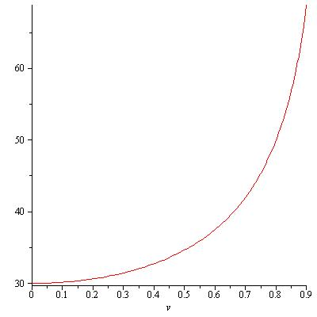
Only one communication will be considered from each presenting author, regardless of the communication's format, that is, only one submission per registration will be allowed. While a registered individual can participate as an author in multiple communications, he will be limited to be responsible of only one of those communications during the Congress.
The Abstract, should introduce the proposed contribution´s subject, summarize its contents, explain any unique aspects, and clearly indicate the specific relevance to the themes of the Conference. Do not sub-divide the text into separate sections. The abstract may contain images, graphs or tables to help draw attention to the subject matter. The bibliographic references should appear as correlative numbers between brackets[1] in Arial 9 points and should be included at the bottom of the abstract. Figures, Schemes and Tables should be inserted in the body text.
Figure 1 – Arial 10 pt Italics
References
- J. Clerk Maxwell, A Treatise on Electricity and Magnetism, 3rd ed., vol. 2. Oxford: Clarendon, 1892, pp.68–73.
- Jin, H., Goryca, M., Janicke, M. T., Crooker, S. A. & Klimov, V. I. J. Am. Chem. Soc. 142, 18160–18173 (2020)

Abstracts should be submitted on-line using the web based abstract submission system operated by the conference. https://www.benasque.org/2023amats/
The abstract shall be submitted as PDF File (Note that this editable file (.doc) is only to facilitate the writing of the abstract.
Once the abstract has been prepared according to the template provided, save the document with a name beginning with the acronym of the area for which it is being submitted followed by the last and first name of the presenting author and the desired type of contribution (oral or poster).
Example: AMatS1_SurnameNameAuthorPresenter_poster.docx

